Adam Edgett

Database Design

Homework 1

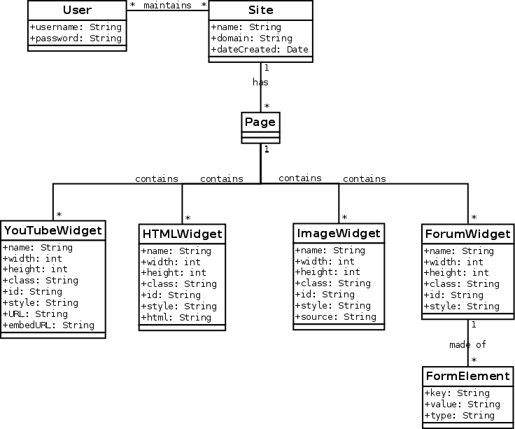

# Initial Design

The users maintain websites that have web pages. These pages contain different widgets that have different content types. The form widget is made up of multiple form elements.

Multiple users can maintain multiple websites (* to *)

A site has multiple pages (1 to *)

A page can have multiple widgets (1 to *)

And a form widget is made up of multiple elements (1 to *)

This diagram shows all the fields and types but not a lot of other information

# Inheritance Design (Generalization)

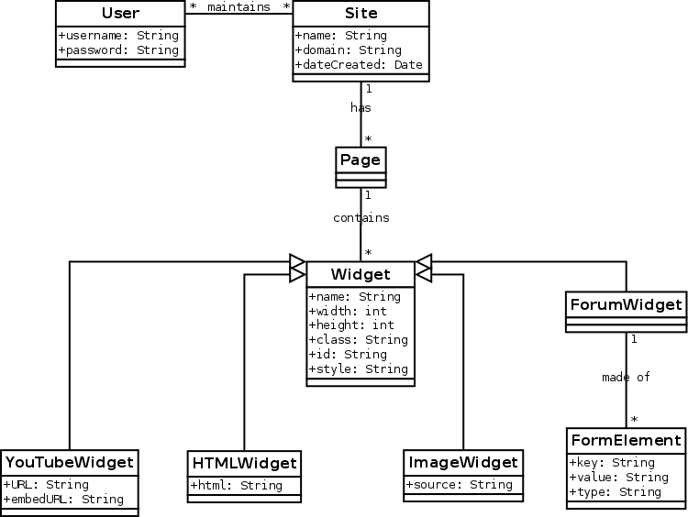

This design merges the common fields of the different widget types to inherit attributes from the super Widget class. This eliminates the redundancy of the Widget class and its subclasses. This design is considerably more simplistic and easy to follow because of the reduced redundancy

# Dependency Design

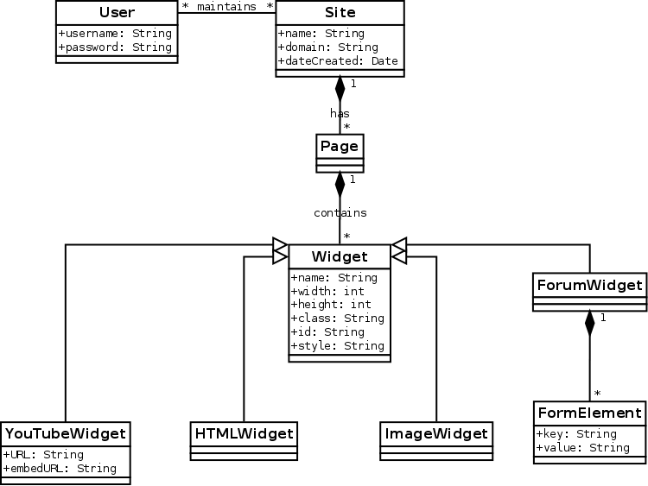

This design adds dependency relationships. This shows when the class deletions should cascade to the child classes.

Since form elements can't exist without the form widget, widgets can't exist without a page, and pages can't exist without a site, these deletions can cascade to the child classes.